* Build File Creation

1. 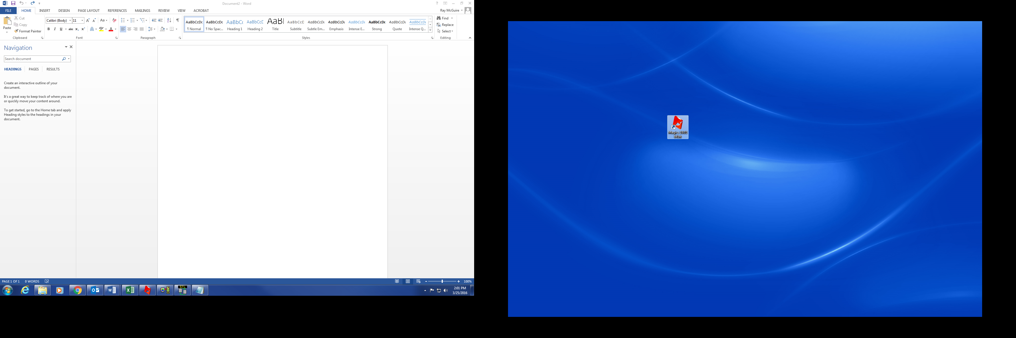Select ‘Magics’ icon from Desktop:
2. 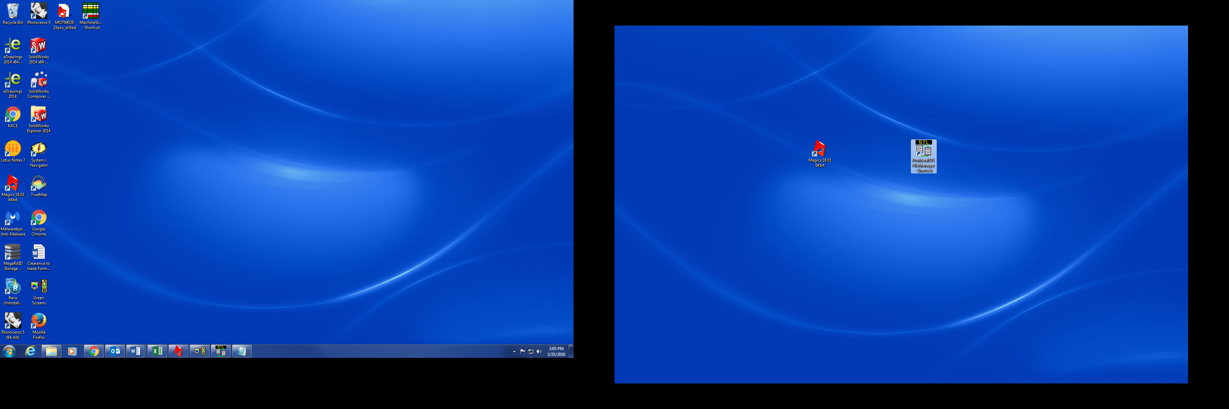Additionally, Open ‘STL File Manager’:
3. On ‘STL File Manager’ drag and drop files from *Stilted STL Files* (center column) to *Build STL Files* (right column):

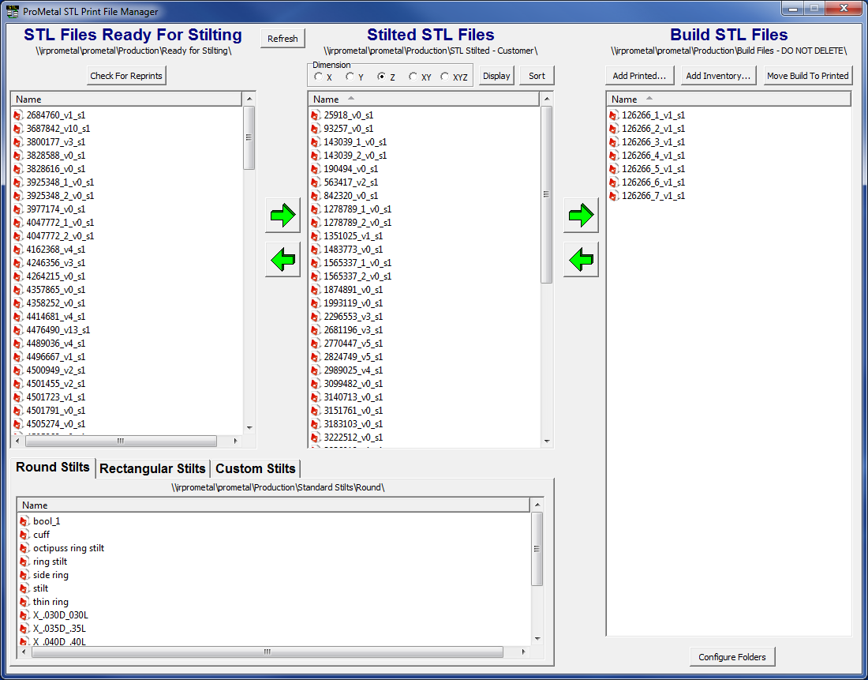

1. Drag files from *Build STL Files* into the scene in ‘Magics’:

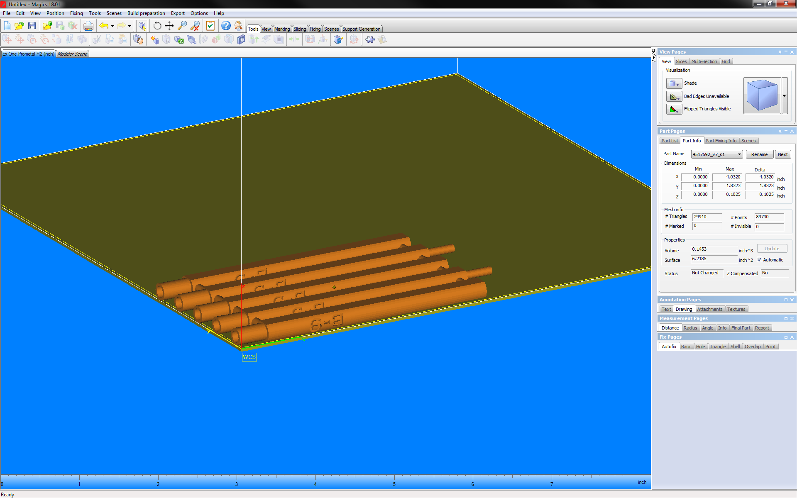

1. Once all files have loaded; from the tool bar, under the ***Tools*** tab, select the *Automatic Placement* tool (puzzle piece):

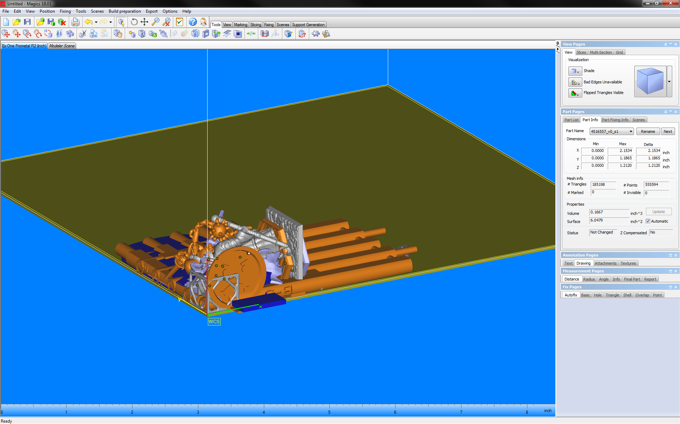

1. When the Dialogue appears enter the appropriate parameters and select ‘OK’:

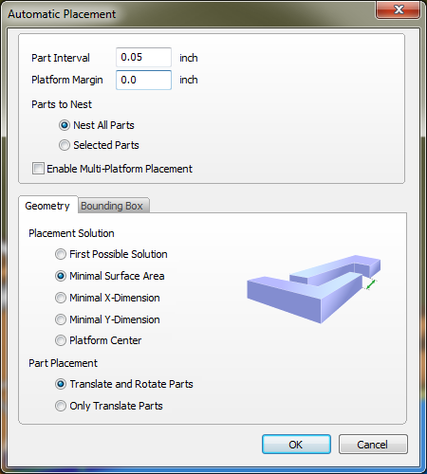

1. Highlight all parts and use the *Merge* tool:

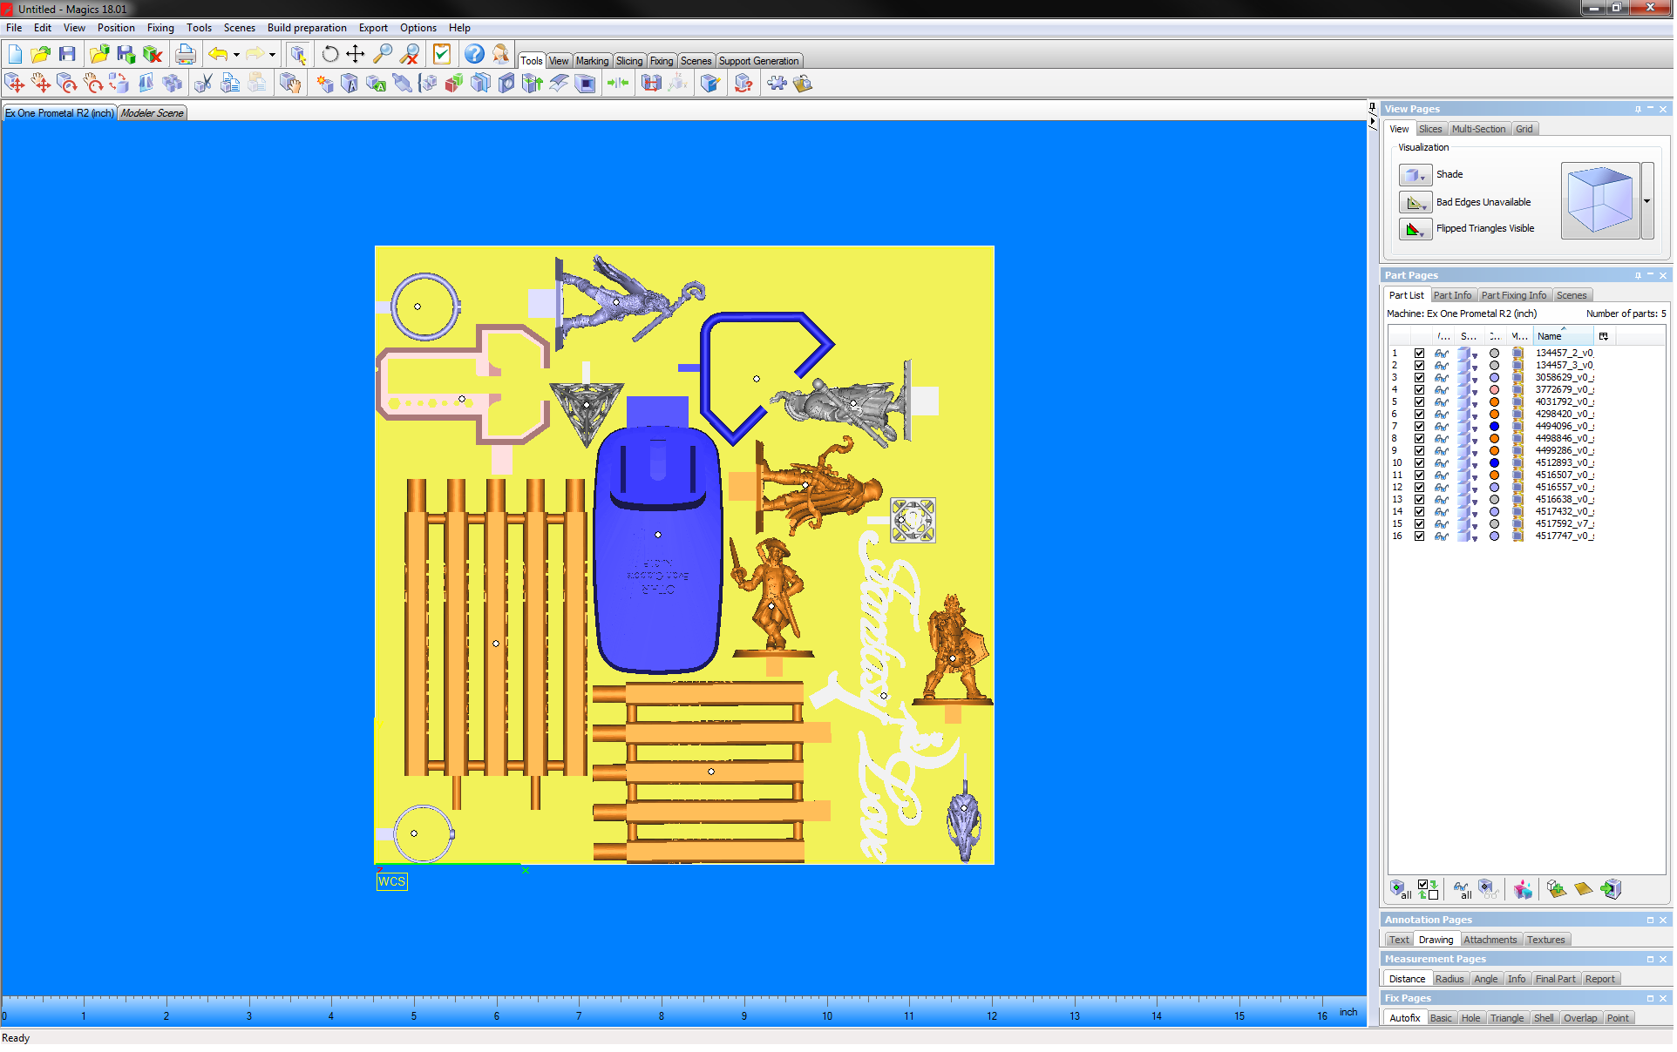

1. After merging the parts, switch to the ***View*** tab in the toolbar and select the *View/Hide Platform* and *View Part Dimensions* buttons:

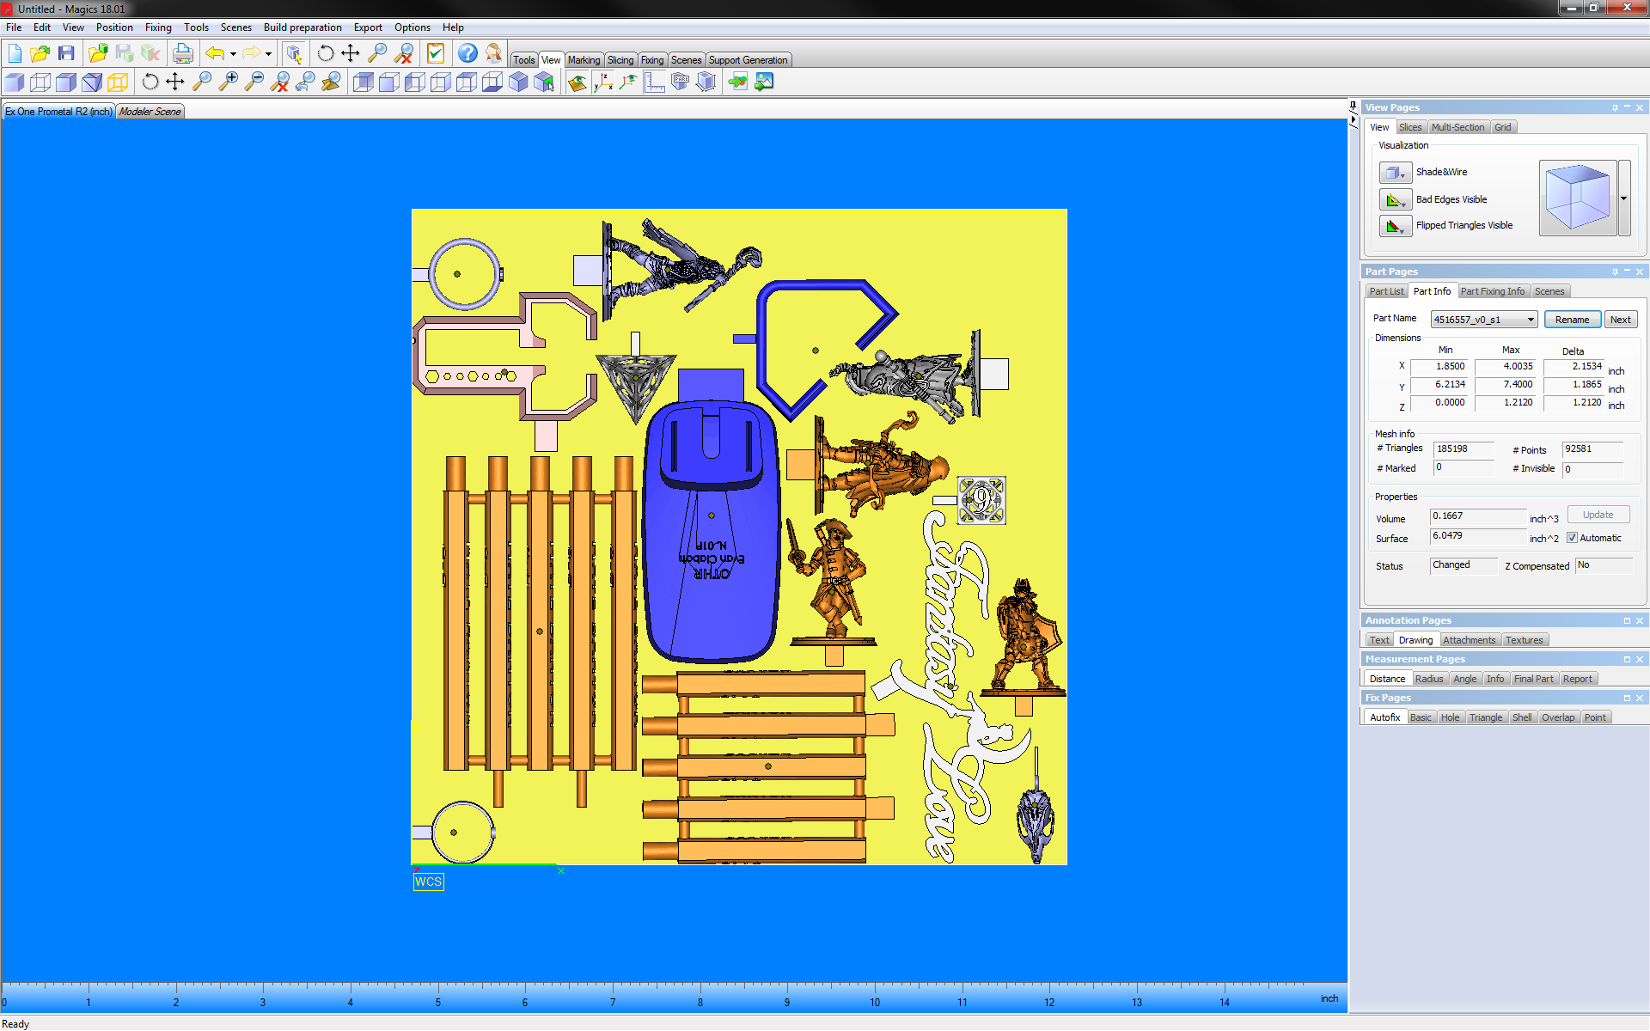

1. Rename your merged ‘Magics’ file, include the MO number and the quantity of parts in the following format:

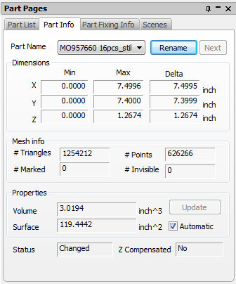

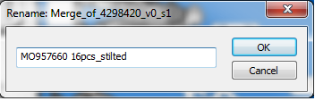

1. Print a 2D image of the build file:



1. Use the *Slice* tool to convert the file to *.cli* format:



1. Change Slice format and Slice Parameters to match the example: 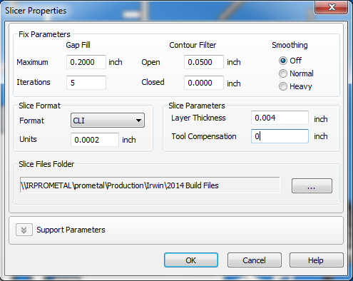
2. The number of layers to be printed will be displayed briefly in the bottom left corner of ‘Magics’:

